What to do:
Make sure the person’s body is higher than their head.
- Tell the person what you are doing and why.
- Wash your hands.
- Ask him/her to lie on her left side if she can. If possible, her body should be a little higher than her head.
- If you have them, put on clean gloves.
- Let the water come down to the end of the tube to get the air out. Then pinch the tubing to stop the
flow.
- Wet the end of the tube with water or an oil, and slide it into the anus. If coherent, ask the person to
take slow, deep breaths to help them relax.
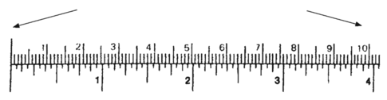
Do not put the tube in more than this much.

- Hold the bag or can just high enough for the water to run in very slowly (about the level of the person’s
hips). It should take about 20 minutes. If the water runs out of their body, the bag may be too high. Lower
the bag so the water runs in more slowly.
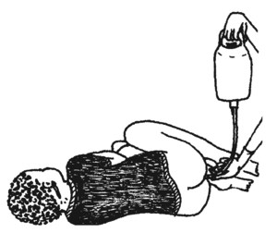
- Gently remove the tube. Tell the person to try and keep the water inside, and that the urge to pass stool
will go away soon. If the person is unconscious, you can hold their buttocks together. Retention enemas
need to be retained for 20-30 minutes to allow the body to
absorb the liquids within the colon.
- Clean and dry the person. Then remove your gloves and wash your
hands.
- If needed, transport the person for medical help right away. For
enemas for those who are in shock - If the person is still in shock,
you can give another enema one hour later. If he/she is not in
shock, try to give sips of rehydration drink as you transport
him/her.

Info and images from: Where There’s No Doctor
www.HealthyPreparedness.blogspot.com

Electrolyte Recipe:
2 cups water
2 tsp.’s sugar / dextrose / honey
1/2 tsp mineral salt
Pinch baking soda

Using warm water works best.
Allow the person to have a bowel movement if it triggers one.
Retain for 20 minutes.
Repeat several times a day.
Hold buttocks closed, if needed, to help person retain the solution for the full 20 minutes.

