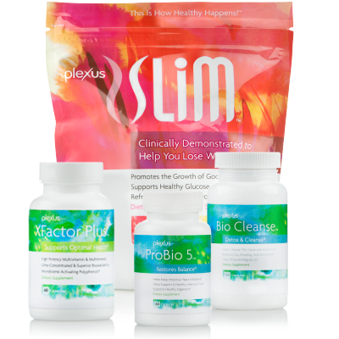

The main Plexus products are the Triplex (the set of three gut healing remedies) and the XFactor Plus (the multi-vitamin containing methylated nutrients). Here’s a bit about each one of those products:
ProBio5: Contains probiotics, digestive enzymes and an anti-fungal (grape seed extract). This product is highly effective at breaking down and eliminating Candida (and an excess of bad bacteria) in the body.
BioCleanse: This is the digestive cleanser. It keeps bowel movements regular and helps flush out Candida on a regular basis. It also provides the body with magnesium (which is one of the most important minerals we need in order to function optimally) and it helps oxygenate and alkalize the digestive system.
Pink Drink: The pink drink helps stabilize blood sugar levels, it boosts liver functions, reduces inflammation, repairs the mitochondria, it feeds the good bacteria in the digestive tract, and helps produce glutathione in the body.
XFactor Plus: This is Plexus’ multi-vitamin that contains methylated B vitamins – especially methyl-folate for those who have a hard time breaking up and using B vitamins. It also contains aloe which has been clinically proven to increase absorption of the nutrients in this multivitamin by up to 300%.
I have found there to be 6 main reasons why Plexus works so well:
🔸1) It eliminates Candida from the body and keeps it in check on a daily basis.
🔸2) It heals the digestive system in 8 different ways.
🔸3) It reduces inflammation in the body.
🔸4) It balances blood sugar levels.
🔸5) It provides the body with bioavailable nutrients.
🔸6) It helps to repair mitochondria and DNA.
When all of these issues are addressed, health can occur. If a person has an illness like Lyme disease, I'd also incorporate #7 >> kick out the pathogens. - and would do so either by using aggressive at-home treatments or treatments through an experienced doctor.

Here’s the best way to take these supplements:
- Morning: Drink PInk Drink and take 2 BioCleanse on an empty stomach. (Adjust amount of BioCleanse you’re taking so you have 2-3 bowel movements consistently every day. Cut back if you have diarrhea.)
- Breakfast: Take 2 XFactor Plus with breakfast.
- Before Bed: Take 1 ProBio5 and 2 BioCleanse.
For the first week take 1 ProBio5. Take 2 during the second week. Take 3 during the third week. And take 4 during the 4th week. Then cut back down to 2 for the 5th week. And then use 1-2 from then on.
The ProBio5 will be breaking down and eliminating Candida from your body. Take some milk thistle capsules and drink plenty of water to help with any die-off (negative symptoms that come up as your body works to clean out the Candida).
You'll be adjusting the BioCleanse to what works for you - you want to have at least 2 bowel movements a day.
Let me know if you have any questions!

